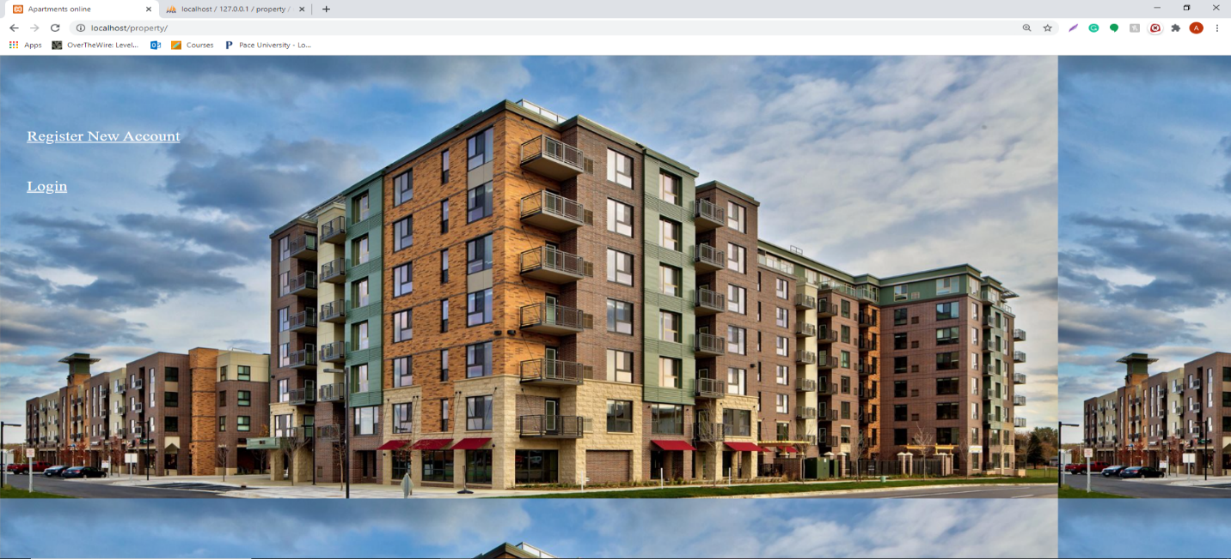

**Index page:-**

**Here we have two functionalities.**

**1) Register new account.**

**2) Login.**

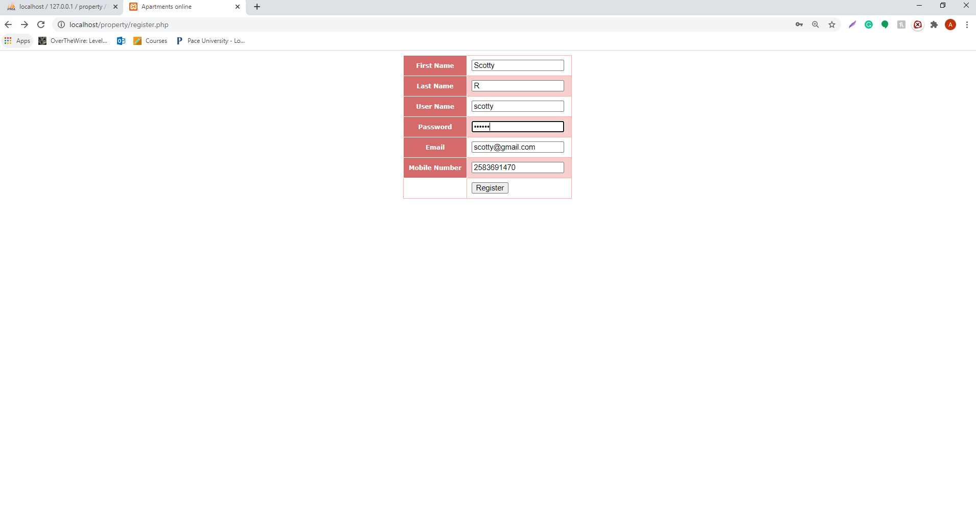

**Displaying Registration page with user credentials in the above screenshot.**

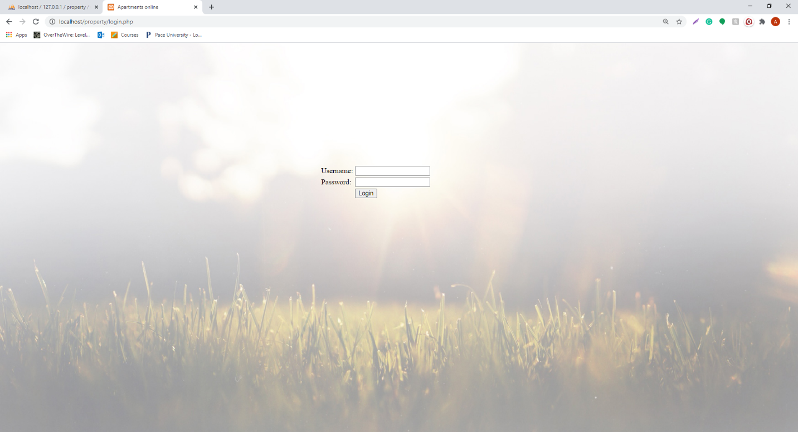

**In the above screenshot, Displaying Login page with username and password. So the user can enter their username and password and can log into the Homepage.**

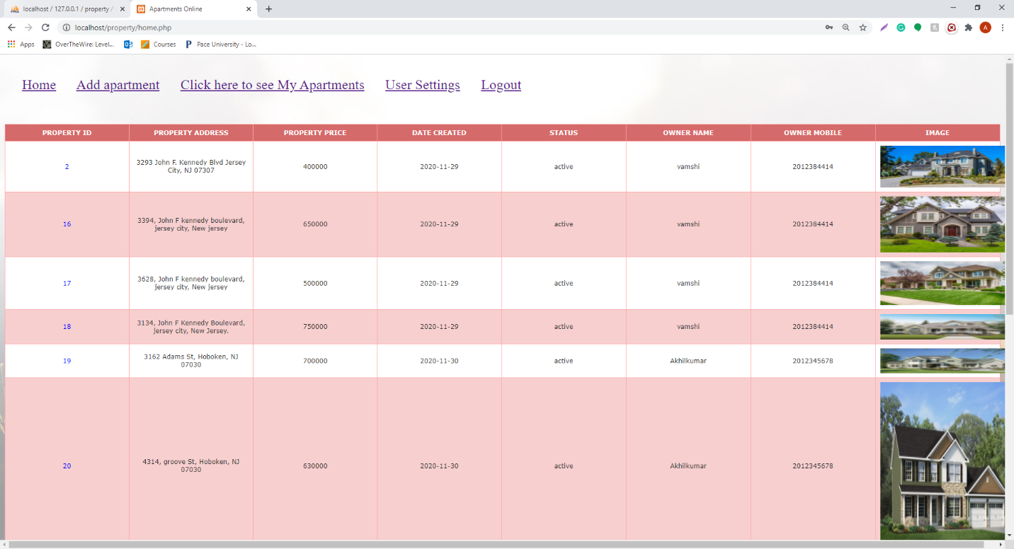

**Displaying homepage with all the properties that are available for sale with price, property ID, property Address, owner name, owner Mobile number. So, the Registered users can access this page and can able to check the property details and can contact the owner by the mobile number provided if they are interested in property**

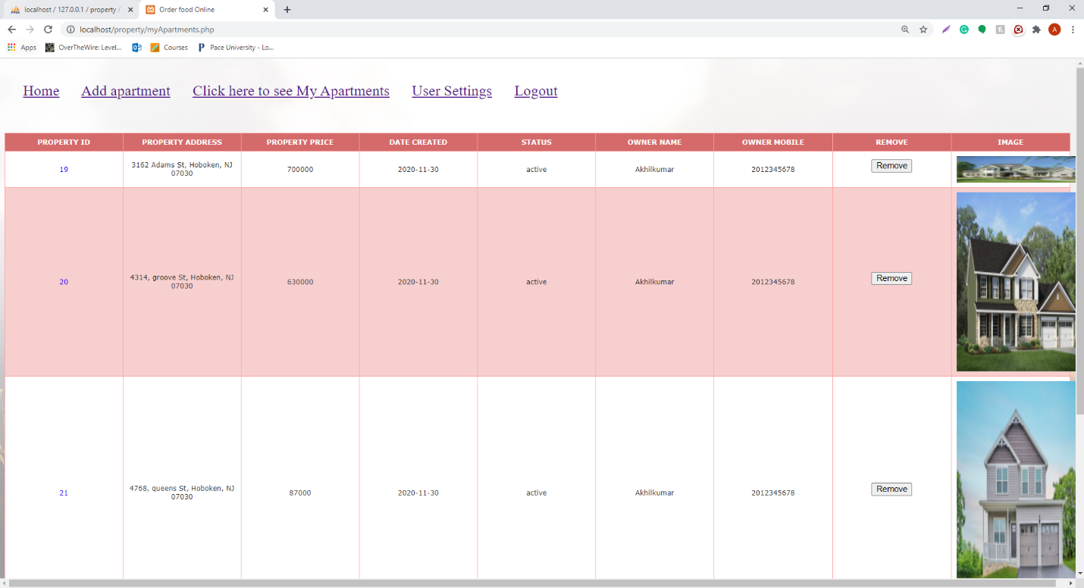

**In the above screenshot,Displaying only the apartments added by a particular user. Here we can see the user can remove the listings that they have added .**

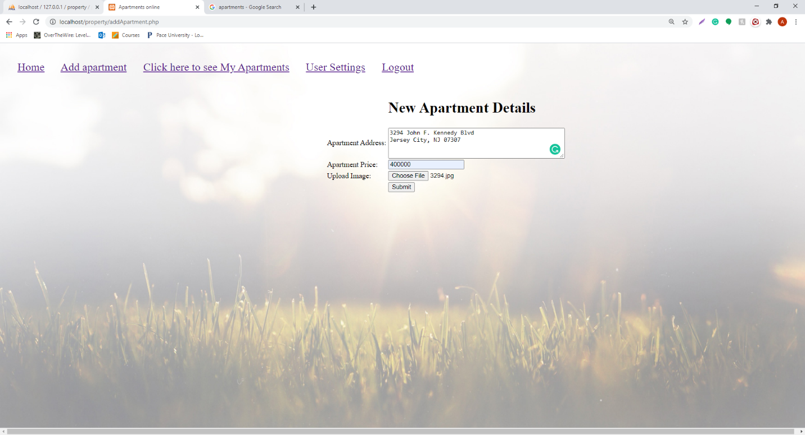

**Displaying the page in which user can add an apartment details by adding address, price, and can upload the image.**

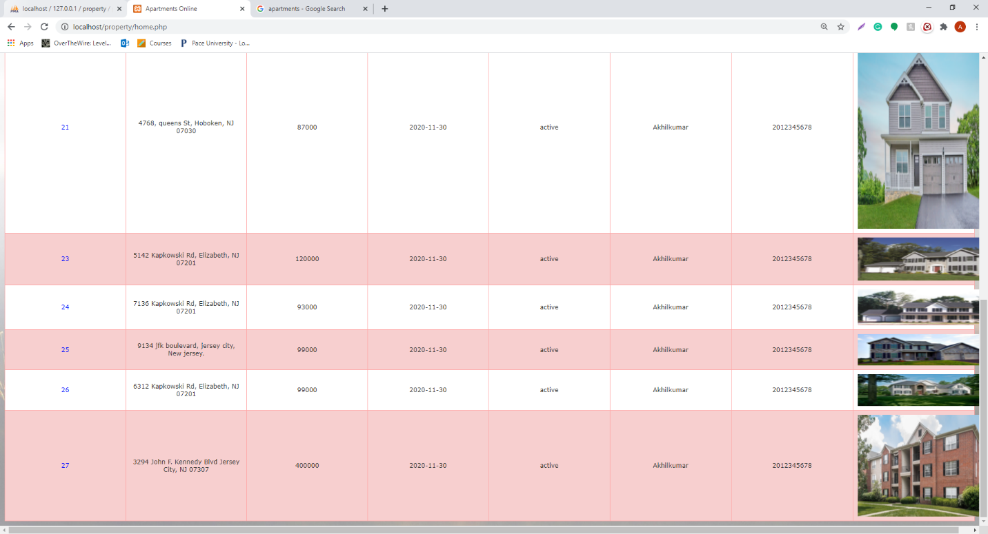

**Displaying home page after user successfully adding the apartment details.**

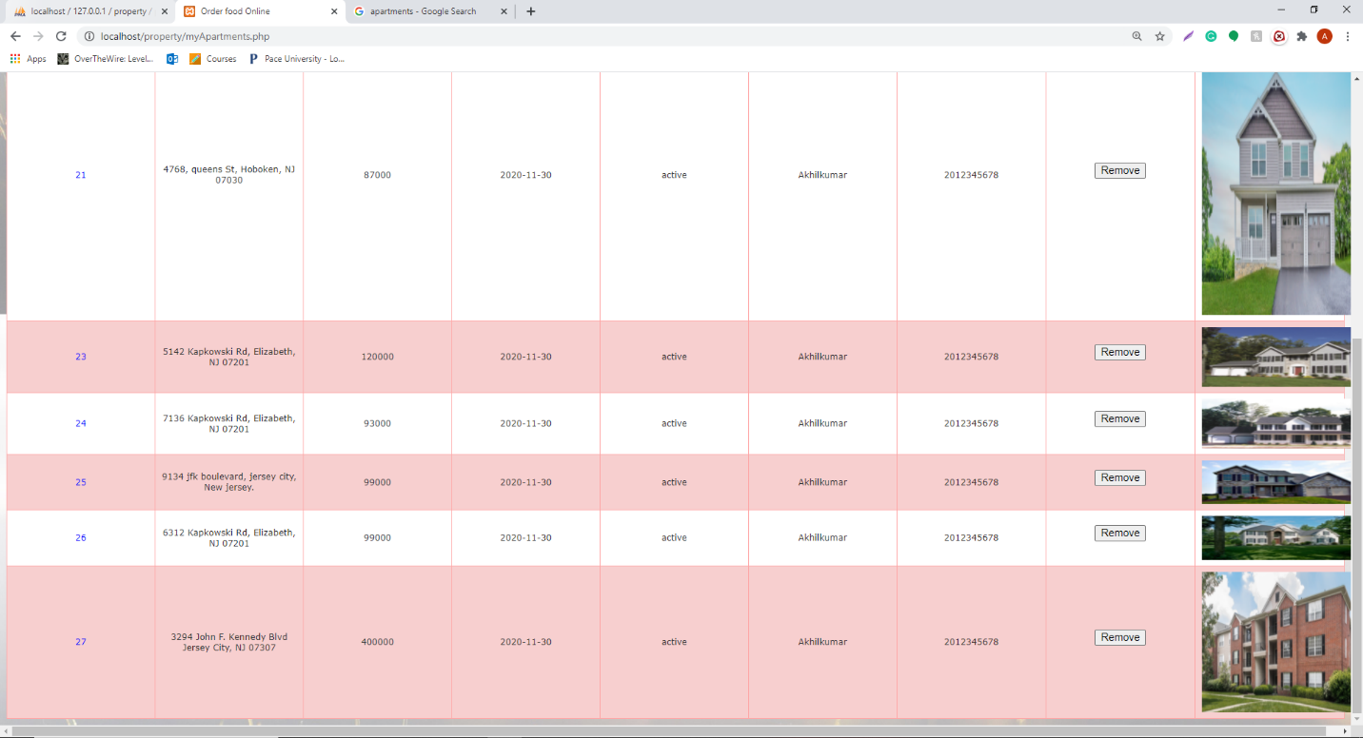

**Displaying only the apartments of a particular user after user successfully adding the apartment details.**

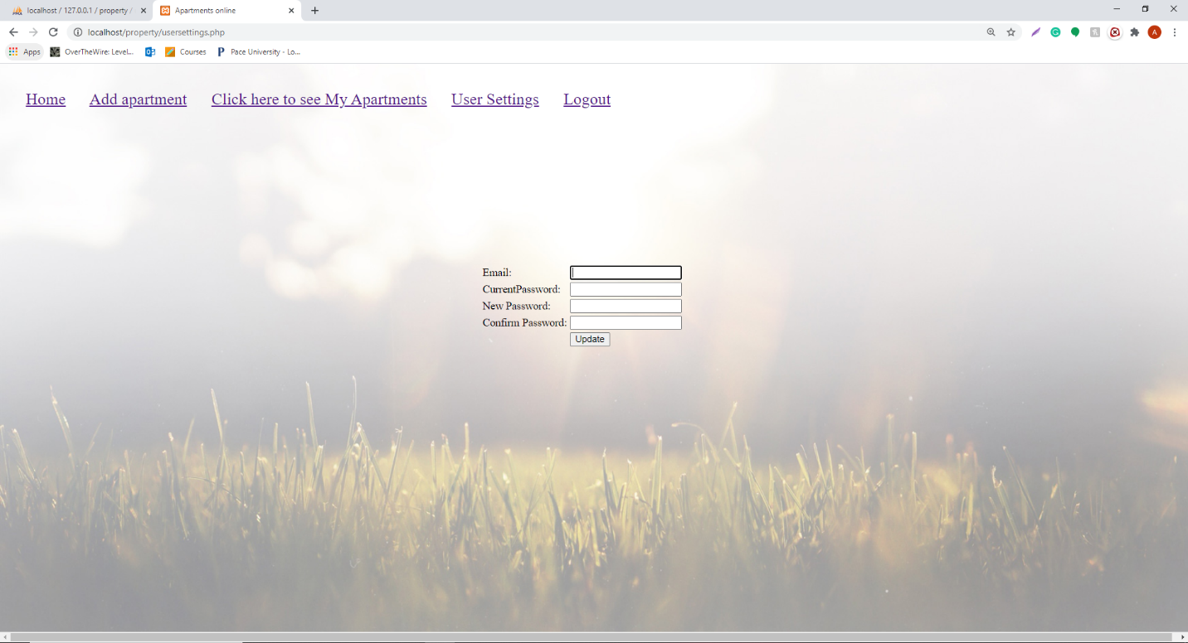

**In the above screenshot, Displaying the user settings page where the user can update his password details.**

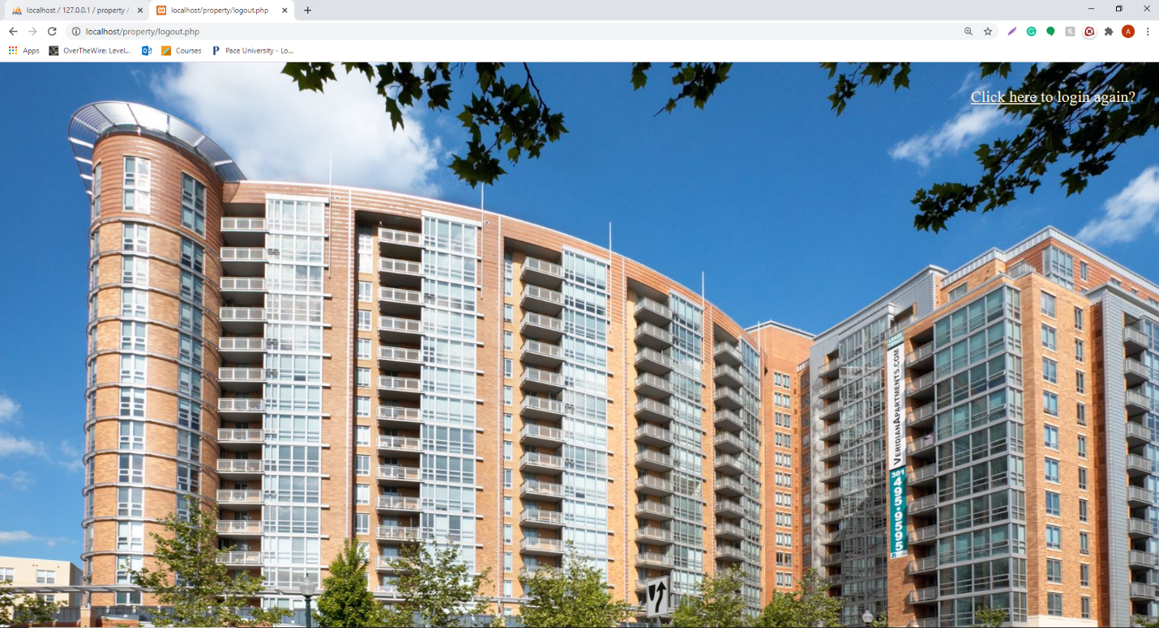

**Displaying the post log out page where the user can login again by clicking the link.**

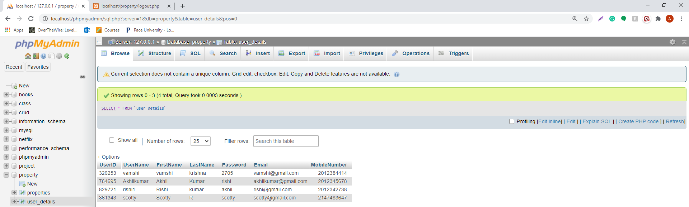

**Displaying the user details in the database.**

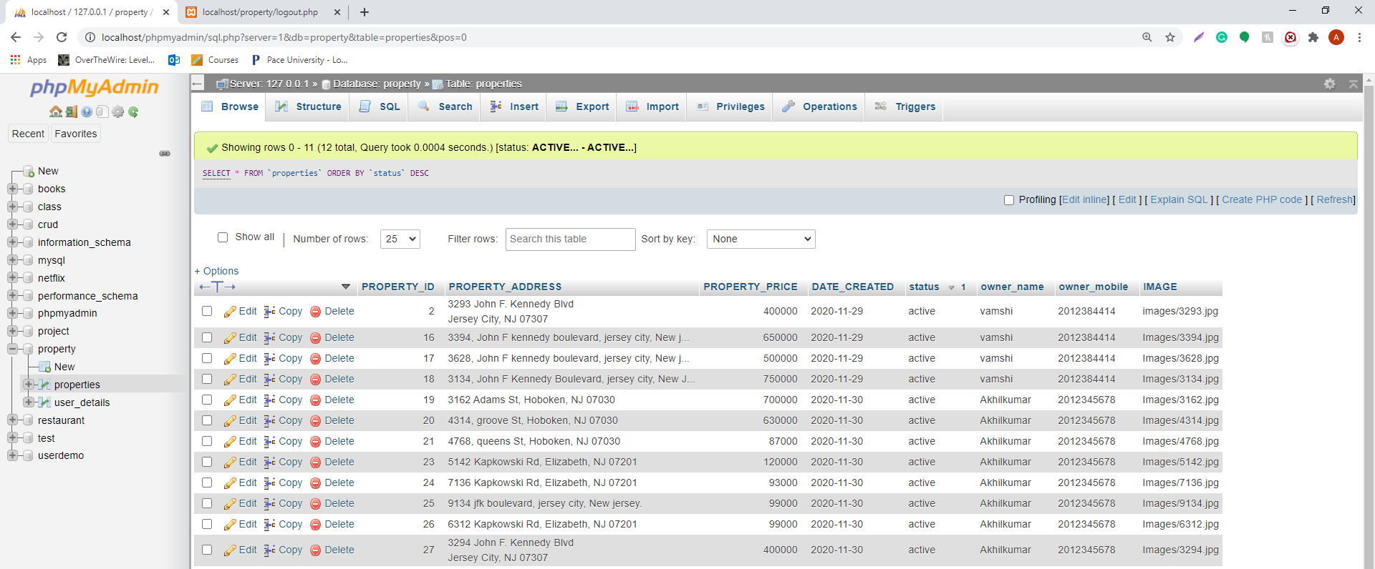

**In the above screenshot, Displaying the properties details in the database.**